|  | **American International University- Bangladesh (AIUB)**  **Faculty of Engineering (FE)** | | | | | | | | | |
| --- | --- | --- | --- | --- | --- | --- | --- | --- | --- | --- |
|  | |  | | | | |  | |  | |
| **Course Name :** | |  | | | | | **Course Code :** | | EEE 1204 | |
| **Semester :** | | Summer 2023-24 | | | | | **Sec :** | |  | |
| **Lab Instructor :** | |  | | | | | **Group :** | |  | |
|  | |  | | | | |  | |  | |
| **Experiment No :** | | 3 | | | | | | | | |
| **Experiment Name :** | | Design of adder and comparator circuits | | | | | | | | |
|  | |  | | | | |  | |  | |
| **Submitted by (NAME):** | |  | | | | **Student ID:** | | |  | |
|  | |  | | | |  | | |  | |
| **Group Members** | | | | | **ID** | | | **Name** | | |
|  | | | | 1. |  | | |  | | |
|  | | | | 2. |  | | |  | | |
|  | | | | 3. |  | | |  | | |
|  | | | | 4. |  | | |  | | |
|  | | | | 5. |  | | |  | | |
|  | | | | 6. |  | | |  | | |
|  | | | | 7. |  | | |  | | |
|  | | | | |  | |  | |  | |
| **Performance Date :** | | |  | | | **Due Date :** | | | |  |
|  | | | | |  | | | | | |

**Marking Rubrics (to be filled by Lab Instructor)**

| Category | Proficient  [6] | Good  [4] | Acceptable  [2] | Unacceptable [1] | Secured Marks |
| --- | --- | --- | --- | --- | --- |
| **Theoretical Background, Methods  & procedures sections** | All information, measures and variables are provided and explained. | All Information provided that is sufficient, but more explanation is needed. | Most information correct, but some information may be missing or inaccurate. | Much information missing and/or inaccurate. |  |
| **Results** | All of the criteria are met; results are described clearly and accurately; | Most criteria are met, but there may be some lack of clarity and/or incorrect information. | Experimental results don’t match exactly with the theoretical values and/or analysis is unclear. | Experimental results are missing or incorrect; |  |
| **Discussion** | Demonstrates thorough and sophisticated understanding. Conclusions drawn are appropriate for analyses; | Hypotheses are clearly stated, but some concluding statements not supported by data or data not well integrated. | Some hypotheses missing or misstated; conclusions not supported by data. | Conclusions don’t match hypotheses, not supported by data; no integration of data from different sources. |  |
| **General formatting** | Title page, placement of figures and figure captions, and other formatting issues all correct. | Minor errors in formatting. | Major errors and/or missing information. | Not proper style in text. |  |
| **Writing & organization** | Writing is strong and easy to understand; ideas are fully elaborated and connected; effective transitions between sentences; no typographic, spelling, or grammatical errors. | Writing is clear and easy to understand; ideas are connected; effective transitions between sentences; minor typographic, spelling, or grammatical errors. | Most of the required criteria are met, but some lack of clarity, typographic, spelling, or grammatical errors are present. | Very unclear, many errors. |  |
| Comments: |  | | | Total Marks  (Out of ): |  |

**Abstract**

This lab experiment aims to design, analyze, and test the functionality of adder and comparator circuits. These fundamental digital circuits are integral to arithmetic operations in computing systems. The study involves implementing half adders, full adders, and magnitude comparators, using both individual logic gates and integrated circuits (ICs). The experiment validates theoretical designs through practical testing and simulation, providing a comprehensive understanding of the behavior of these circuits.

**Problem Statement**

In digital electronics, efficient arithmetic operations and comparisons are crucial for processing data. Designing circuits like adders and comparators using basic gates is a foundational skill in digital logic design. The challenge is to create accurate and reliable adder and comparator circuits, analyze their performance, and understand their applications in larger digital systems.

**Objectives**

1. To design and construct half adder, full adder, and magnitude comparator circuits.
2. To understand the logic behind binary addition and comparison of binary numbers.
3. To validate the theoretical outputs through practical experimentation and simulation.
4. To develop skills in using digital trainer boards and ICs for implementing digital circuits.

**Theory**

Adders and comparators are essential combinational logic circuits used in arithmetic and logical computations.

**Adders**

An adder is a digital circuit that performs addition of binary numbers. It is a key component of an Arithmetic Logic Unit

**Half Adder**:

• S=A⊕B

• Cout=A⋅B

**Full Adder**:

• S=A⊕B⊕Cin

• Cout=(A⊕B)⋅Cin+A⋅B

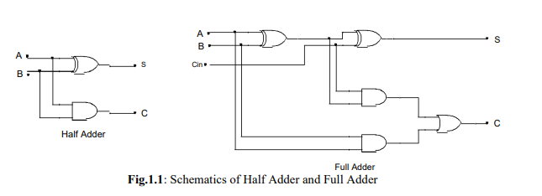

**Comparators**

A magnitude comparator is a combinational circuit that compares two binary numbers and determines if one is greater than, less than, or equal to the other.

* **1-Bit Comparator Logic:**

A=B if, A=B=0 or A=B=1;

A>B if A=1 and B=0;

A<B if A=0 and B=1;

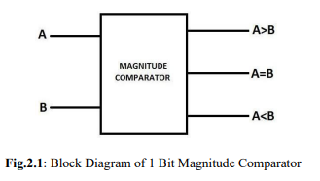

The SOP expressions for the output lines can be written as

(A=B)= A’B’+AB;

(A<B)= AB’;

A>B)=A’B;

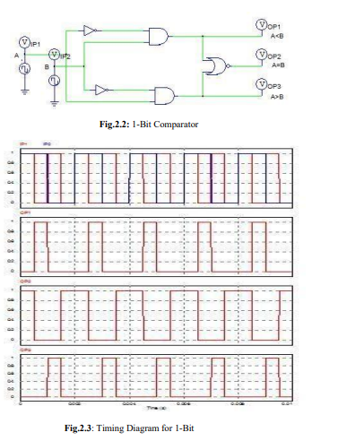

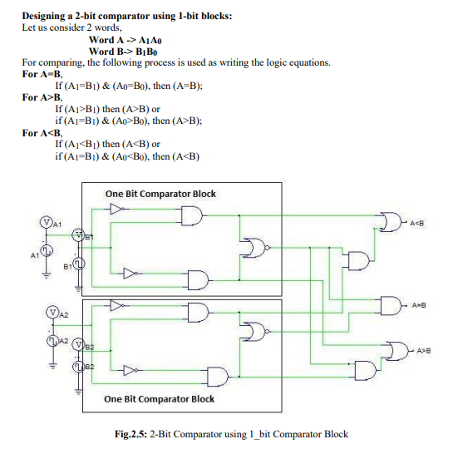

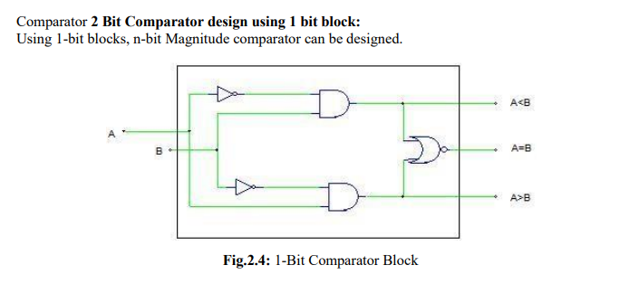

**List of Components:**

1. Digital Trainer Board
2. IC 7408 (AND Gate): 2 pcs
3. IC 7404 (NOT Gate): 2 pcs
4. IC 7486 (XOR Gate): 2 pcs
5. IC 7483 (4-bit Full Adder): 1 pc
6. Connecting Wires
7. LEDs and Toggle Switches
8. Power Supply (+5V DC)

**Experimental Setup:**

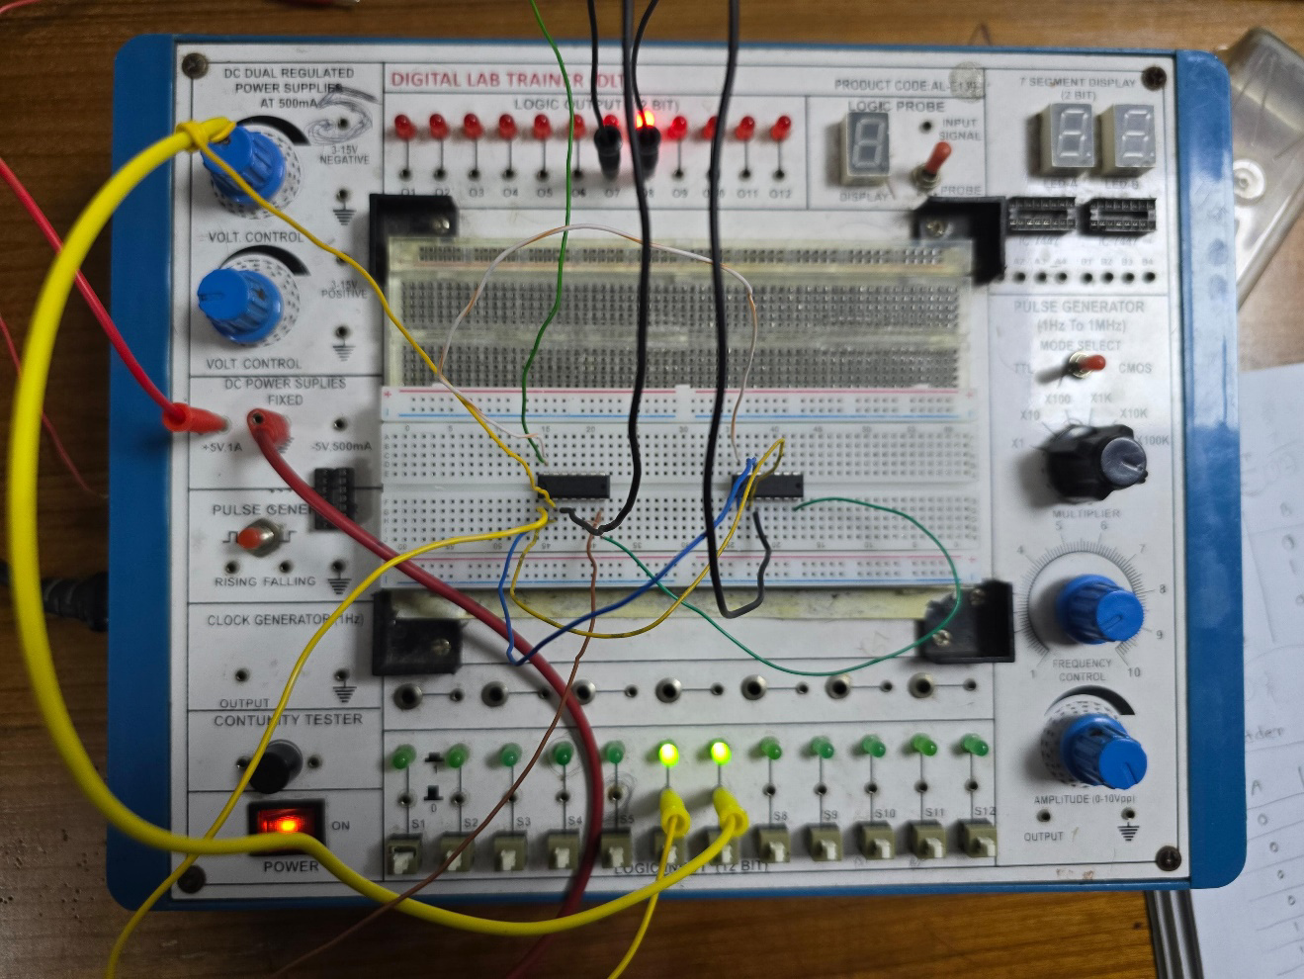

**Figure 1: Half Adder**

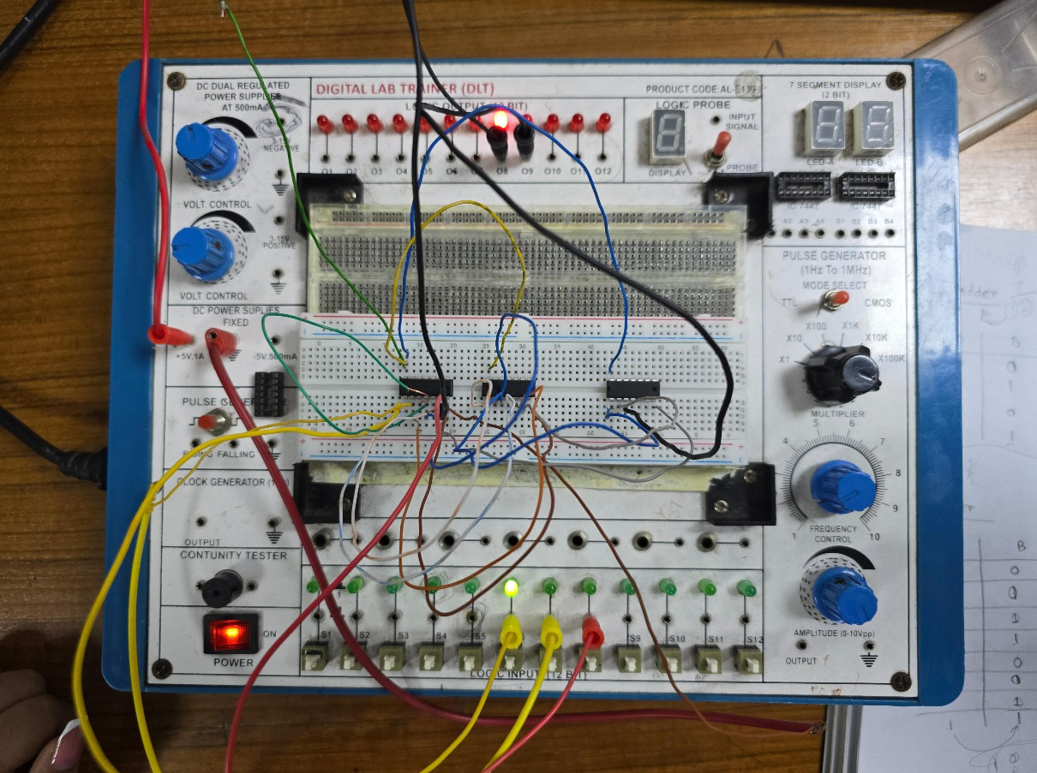

**Figure 2 : Full Adder**

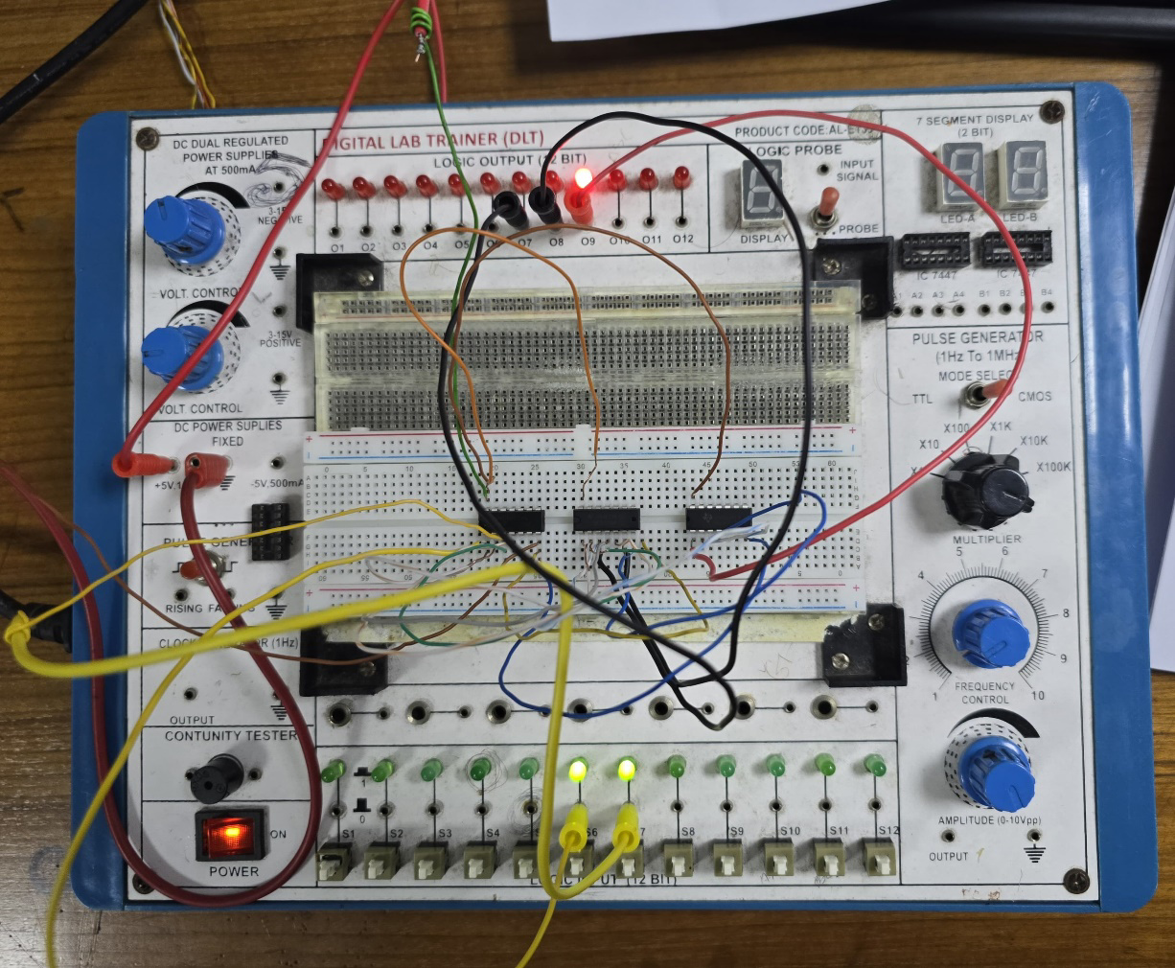

**Figure 3: 1 bit comparator**

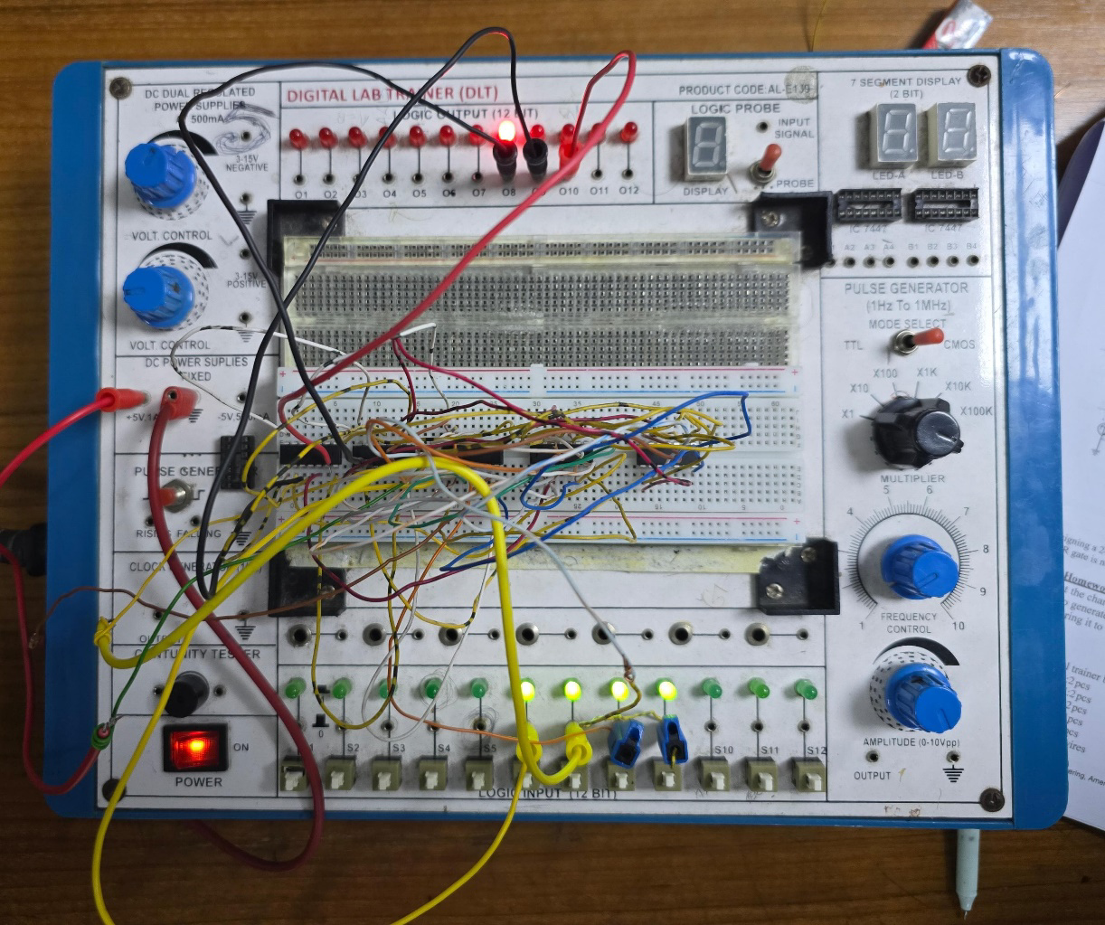

**Figure 4: 2 bit comparator using 1 bit comparator**

**Data Table:**

**Truth Table: Half Adder**

| **A** | **B** | **S** | **Cout** |
| --- | --- | --- | --- |
| 0 | 0 | 0 | 0 |
| 0 | 1 | 1 | 0 |
| 1 | 0 | 1 | 0 |
| 1 | 1 | 0 | 1 |

**Truth Table: Full Adder**

| **A** | **B** | **Cin** | **S** | **Cout** |
| --- | --- | --- | --- | --- |
| 0 | 0 | 0 | 0 | 0 |
| 0 | 0 | 1 | 1 | 0 |
| 0 | 1 | 0 | 1 | 0 |
| 0 | 1 | 1 | 0 | 1 |
| 1 | 0 | 0 | 1 | 0 |
| 1 | 0 | 1 | 0 | 1 |
| 1 | 1 | 0 | 0 | 1 |
| 1 | 1 | 1 | 1 | 1 |

**Truth Table for 1 bit comparator:**

| **A** | **B** | **A = B** | **A > B** | **A < B** |
| --- | --- | --- | --- | --- |
| 0 | 0 | 1 | 0 | 0 |
| 0 | 1 | 0 | 0 | 1 |
| 1 | 0 | 0 | 1 | 0 |
| 1 | 1 | 1 | 0 | 0 |

**Truth Table for 2-Bit Comparator:**

| **A1** | **A0** | **B1** | **B0** | **A>B** | **A=B** | **A<B** |
| --- | --- | --- | --- | --- | --- | --- |
| **0** | **0** | **0** | **0** | **0** | **1** | **0** |
| **0** | **0** | **0** | **1** | **0** | **0** | **1** |
| **0** | **0** | **1** | **0** | **0** | **0** | **1** |
| **0** | **0** | **1** | **1** | **0** | **0** | **1** |
| **0** | **1** | **0** | **0** | **1** | **0** | **0** |
| **0** | **1** | **0** | **1** | **0** | **1** | **0** |
| **0** | **1** | **1** | **0** | **0** | **0** | **1** |
| **0** | **1** | **1** | **1** | **0** | **0** | **1** |
| **1** | **0** | **0** | **0** | **1** | **0** | **0** |
| **1** | **0** | **0** | **1** | **1** | **0** | **0** |
| **1** | **0** | **1** | **0** | **0** | **1** | **0** |
| **1** | **0** | **1** | **1** | **0** | **0** | **1** |
| **1** | **1** | **0** | **0** | **1** | **0** | **0** |
| **1** | **1** | **0** | **1** | **1** | **0** | **0** |
| **1** | **1** | **1** | **0** | **1** | **0** | **0** |
| **1** | **1** | **1** | **1** | **0** | **1** | **0** |

**Simulation:**

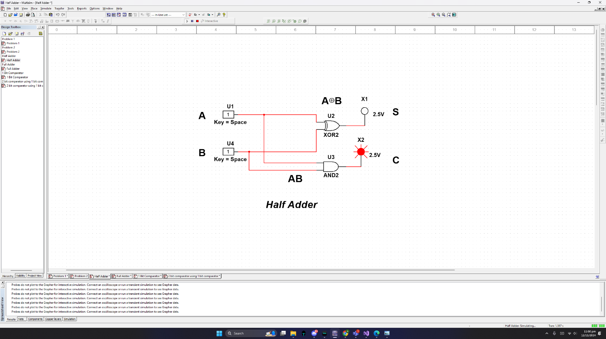

**Simulation 1: Half Adder**

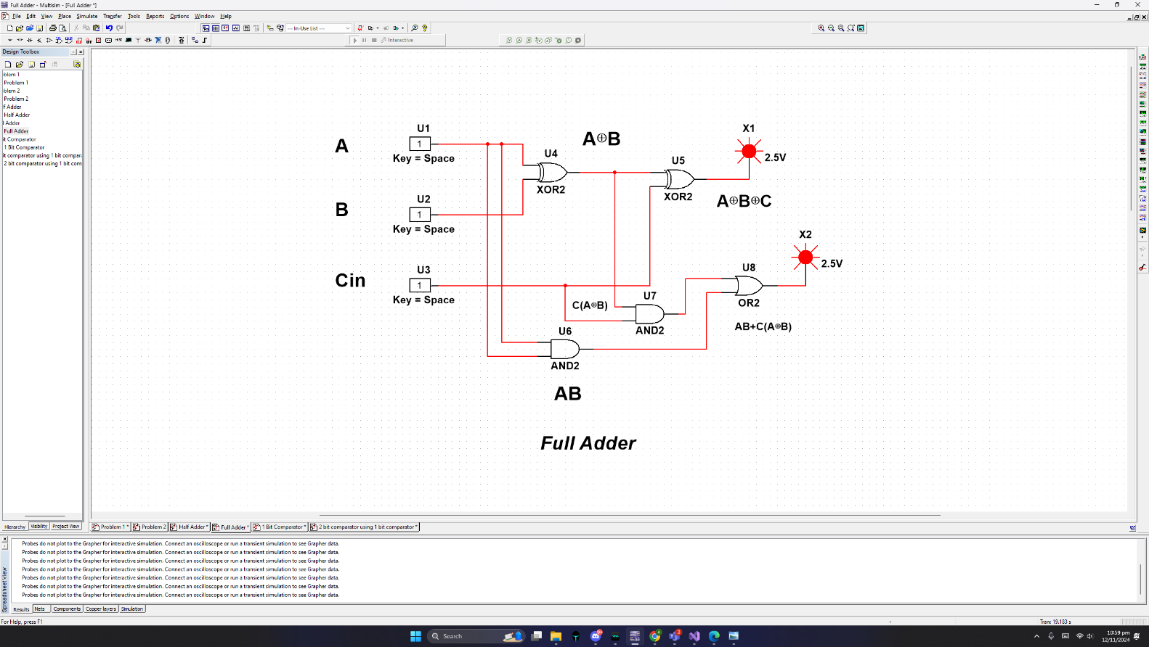

**Simulation 2: Full Adder**

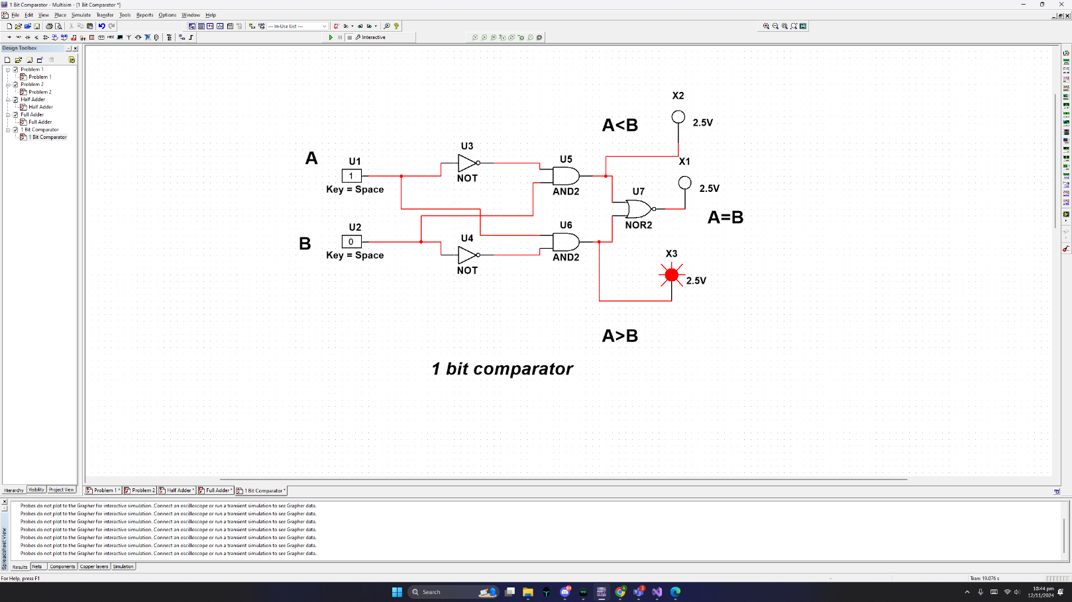

**Simulation 3: 1 Bit Comparator**

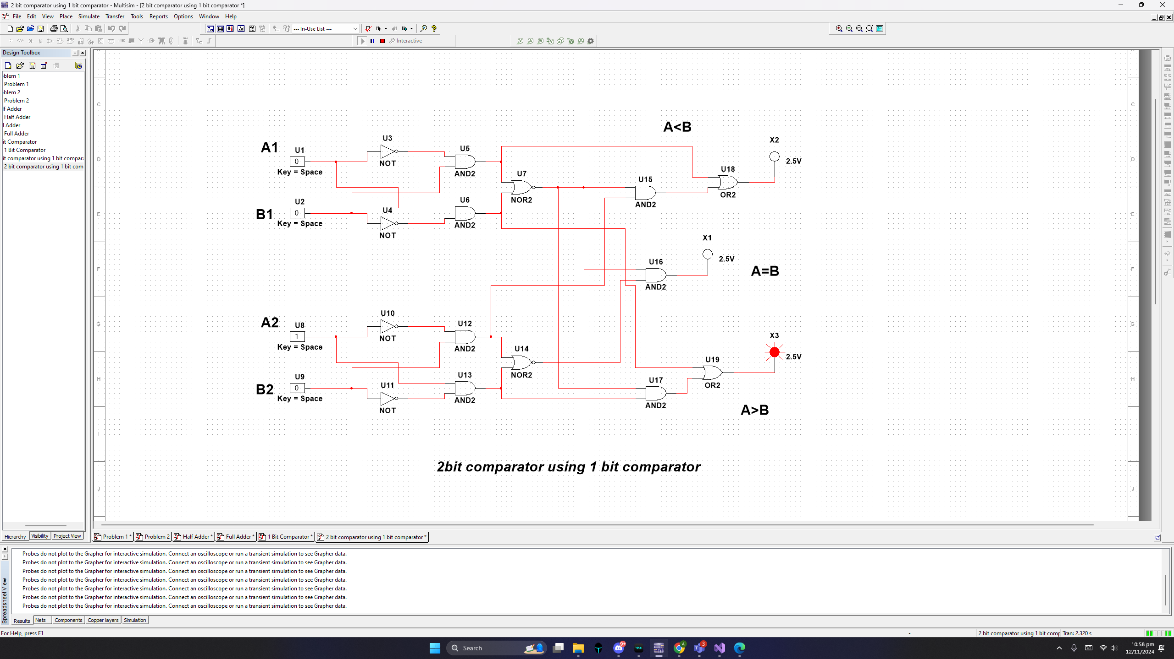

**Simulation 4: 2 bit comparator using 1 bit comparator**

**Discussion**

In this experiment, we designed and tested adder and comparator circuits using digital ICs on a trainer board. For the adder circuits, we started by building half adders and full adders using XOR, AND, and OR gates to perform binary addition. The half adder was used to add two single-bit inputs, while the full adder included an input carry to handle multi-bit addition tasks. We then implemented a 4-bit adder using the IC 7483, which allowed for efficient multi-bit additions. The outputs observed during testing were consistent with the expected results, confirming the accuracy of our design.

For the comparator circuits, we began by constructing a 1-bit comparator using basic logic gates to evaluate equality, greater-than, and less-than conditions between two single-bit inputs. We extended this design to a 2-bit comparator by connecting two 1-bit comparator blocks, incorporating additional gates for accurate multi-bit comparisons. The experimental outputs matched the predicted truth table values.

Simulations of both adder and comparator circuits were conducted using PSIM software, and the practical results closely aligned with the simulations. The successful implementation and verification of these circuits provided a solid understanding of fundamental digital logic operations used in computational systems.

**Reference**

<http://www.circuitstoday.com/half-adder-and-full-adder>

